**FYP Topic: File Encryption and Decryption System**

**Subject: Python coding language using PyCharm software**

**Deadline: 25 Feb 2022**

**System**

1. System must have browse option to choose file from the computer to encrypt/ decrypt file

2. System must have file destination option to save the encrypted file/folder in the computer

3. The system must be able to encrypt and decrypt:

- Files: a) Image files (jpeg, png, ico, bmp, gif)

b) Microsoft Office files (docx, ppt, xls) and txt

c) PDF files

- Folders: RAR, ZIP and normal pc folders

4. A password must be set for the file/folder to encrypt the file/folder. After completing encryption, the file/folder should be saved in encrypted format (where if the file/folder is opened, it will be unreadable - hashed)

5. There must be an error message saying password doesn't match if wrong password is used to decrypt

6. Password strength (8 characters long, minimum 1 uppercase letter and lowercase, two numbers and one special character)

7. Password cannot be copy paste, an error message should appear saying the user should type the password according to the requirements.

8. Confirm password option should be included.

9. System will be using AES-256 algorithm to encrypt and decrypt files/folders

10. To encrypt and decrypt file/folder requires the same password.

11. A file integrity checker function which checks hash values of file should be added in the system.

12. When file is encrypted, a unique file ID, for example F5516, should be assigned and hash value of the file should be calculated and stored. The unique file ID should be displayed in a pop-up message at the system for the user to see it. The hash value is stored in database based on the unique file ID generated. When the same file is decrypted, the same password used for encryption should be used to decrypt the file successfully.

13. File ID, hash value of the file should be stored in database.

14. If the user inputs the wrong password more than 3 times to decrypt that one particular file/folder, that particular file/folder will be deleted automatically.

15. If password section and confirm password section does not match, an error should display.

16. System should be incorporated with Event Viewer (Windows) to track back any unwanted events occurring in the system. Each time the database of the system gets connected, logs are generated using the Windows operating system Event Viewer function.

**Sample interface of system**

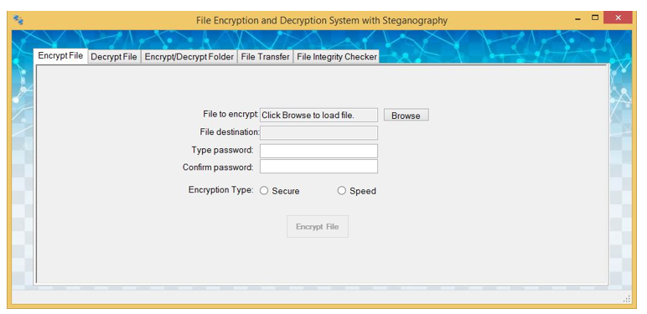

System functions will only be Encrypt file, Decrypt file, Encrypt folder, Decrypt folder and File integrity checker.

**Sample interface for File integrity Checker**

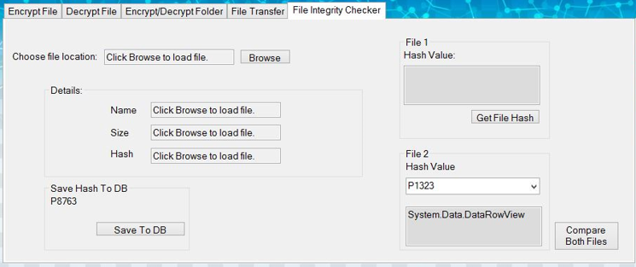

* Once the encrypted file is selected through the browse option, the name, size and the hash value of the file will be displayed. Below hash value, a dropdown column to select file id where all the file ID stored in database when encryption is done should be listed.
* User will then choose the File ID that he received when he encrypted the file earlier.
* Then, an option called “check file integrity” should be added at below where once user clicks it, the system will get the hash value from database of the file ID he chose and compare it with the hash value displayed when he chose the file to check its integrity. If there’s a difference in hash value, a pop-up message saying file has been modified should be displayed. If there’s no difference, a pop-up message saying file has not been modified should be displayed.
* The image shows only a sample on how the file integrity check should look like. The “save hash to DB” section and the right-side of the image “File 1 hash value and file 2 hash value” is not needed.

**Sample of encrypted file (hashed) being accessed without decrypting**

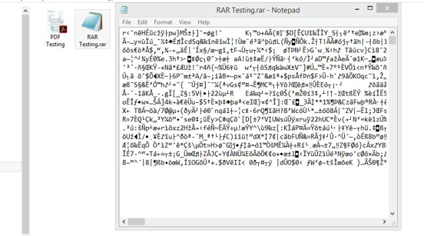

**Documentation**

Table of Contents

Acknowledgement

Chapter 1: Introduction

1.1 Background to the Project

1.1.1. Introduction to the Project System

1.1.2. Encryption

1.1.3. Hashing

1.2. Problem Context

1.3. Rationale

1.4. Potential Benefits

1.4.1. Tangible Benefits

1.4.2. Intangible Benefits

1.5. Target Users

1.6. Scope and Objectives

1.6.1. Aim

1.6.2. Objectives

1.6.3. Deliverables

1.6.4. Nature of Challenge

1.7. Project Overview and Plan

Project Plan

Chapter 2: Literature Review

2.1 Literature Review

2.2. Domain Research

2.2.1. Cryptographic Algorithms

2.2.2. Encryption and Decryption Standards

2.2.3. Advanced Encryption Standard (AES) Algorithm

2.2.4. Data Encryption Standard (DES)

2.2.5. Initialization Vector (IV)

2.2.6. Secure Hashing Algorithm (SHA)

2.2.7. Homomorphic Encryption

2.2.8. Whirlpool Hash

2.3. Technical Research

2.3.1. Existing and Similar Systems

2.3.2. Comparison between Existing and Similar Systems

2.4. Development/Deployment

2.4.1. Programming Language Chosen

2.4.2. IDE Chosen

2.4.3. Library Chosen

2.4.4. Database Management System Chosen

2.4.5. Operating System Chosen

2.4.6. Web Server Chosen

2.4.7. Web Browser Chosen

2.4.8. Development/Deployment Conclusion

2.5. Conclusion

Chapter 3: Development Methodology

3.1 The Chosen Methodology

3.1.1 SSADM

Overview of the diagrams associated with SSADM

Overview on how the proposed system will proceed using SSADM

3.1.2 Rational Unified Process (RUP)

3.1.3 Rapid Application Method (RAD)

3.2 Comparison of Methodology Chosen

3.3 Justification of Selected Methodology (RAD)

3.4 Implementation of the Selected Methodology

Chapter 4: Primary Research

4.1 Introduction

4.1.1 Questionnaire

4.1.2 Interview

4.2 Design

4.2.1. Questionnaire Design

4.2.2. Interview Design

Chapter 5: Requirements Validation

5.1 Analysis of Data

5.1.1 Analysis of Data through Questionnaire

5.1.2 Analysis of Data through Interview

5.2 Conclusion

Chapter 6: System Architecture

6.1 Introduction

6.2 Abstract Architecture

6.2.1 System Design

6.2.1.1 Use CASE Diagram

6.2.1.2 Use CASE Specification

6.2.1.3 Class Diagram

6.2.1.4 Activity Diagram

6.2.1.4.1 Activity Diagram for File Encryption

6.2.1.4.2 Activity Diagram for File Decryption

6.2.1.4.3 Activity Diagram for Folder Encryption

6.2.1.4.4 Activity Diagram for Folder Decryption

6.2.1.4.5 Activity Diagram for File Integrity Checker

6.3 Database Design

6.3.1 Entity Relationship Diagram

6.3.2 Database Table Structure

6.4 Interface Design

6.4.1 Storyboard of the Developed System

Chapter 7: PROJECT PLAN

7.1 Details of the release plan

7.1.1 Phase One

7.1.2 Phase Two

7.1.3 Phase Three

7.1.4 Phases Four

7.2 Release Plan

7.3 Testing

7.3.1 Test Plan

7.3.1.1 Test Plan for Unit Testing

7.3.1.2 Test Plan for Integration Testing

7.3.1.3 Design for User Acceptance Test (UAT)

Chapter 8: Implementation

Screenshots of the System

File Encryption

File Decryption

Folder Encryption

Folder Decryption

File Integrity Checker

Screenshots of Sample Codes

File Encryption

File Decryption

Folder Encrypt/Decrypt

File Integrity Checker

Chapter 9: System Validation

9.1 Unit Testing

9.1.1 File Encryption Validation

9.1.2 Type of Files for Encryption (Validation)

9.1.3 File Decryption Validation

9.1.4 Type of Files for Decryption (Validation)

9.1.5 Folder Encryption Validation

9.1.6 Folder Decryption Validation

9.1.7 File Integrity Checker Validation

9.2 Integration Testing

9.3 User Acceptance Test

9.3.1 Analysis of UAT for Normal Users

9.3.2 Analysis of UAT for Industry Experts

9.4 Summary

Chapter 10: Conclusions & Reflections

10.1 Critical Evaluation

10.2 Limitations and Future Enhancements

10.3 Lessons Learnt

10.4 Conclusion

For chapter 2.2: Domain Research

* Provide Images for the relevant discussions.

For chapter 2.4: Development/Deployment

* For programming language chosen, compare Python language and C++ and justify why Python language is chosen.
* For IDE chosen, compare PyCharm and Visual Studio 2019 and justify why PyCharm is chosen
* Provide images for library chosen and operating system chosen.

For chapter 3: Development Methodology

* Specify each methodology with explanations, advantage and disadvantage.
* Do comparison between RUP and RAD. RAD will be the chosen methodology.

For chapter 5: Requirements Validation

* Evaluate 30 Questionnaire responses and 2 interviews.